Vulnerability Analysis of CVE-2026-21236 – A heap-based overflow in Microsoft Windows Kernel Driver AFD.sys
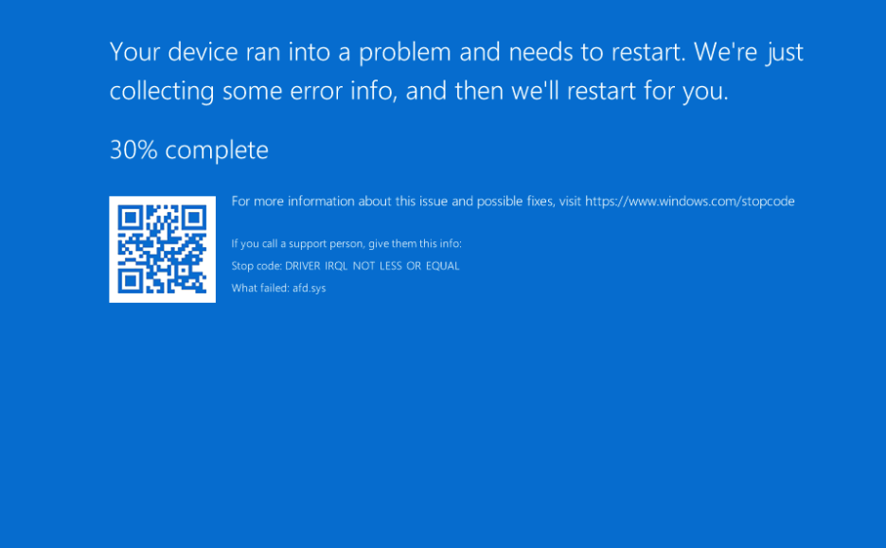

Table of Contents
1. Introduction 3
1.1. What is AFD? 3
1.2. What is SAN? 4
1.3. Environment 4
2. Analysis 5
2.1. Patch diffing 5
2.2. Dynamic Analysis 7
2.3. Vulnerability analysis 12
3. Proof of Concept (POC) 14
3.1. Creating the POC code 14
4. Conclusion 25
5. Acknowledgements 25
6. Appendix A 26
6.1. AI Patch Diffing 26

- Introduction
Our Exploit Development Group (EDG) offers internal secondment opportunities to willing NCC consultants that want to try their hand in developing exploits or analyzing complex bugs. In this secondment, Emily Liu decided to work on Windows CVEs. This blog post presents a patch diff, vulnerability analysis, and proof-of-concept generation of CVE-2026-21236 - a heap-based buffer overflow in afd.sys, the kernel-mode driver underpinning Windows socket operations. Patched by Microsoft on February 11, 2026, the vulnerability resides in the SAN connect handling path and carries an Elevation of Privilege impact, allowing a local attacker to corrupt kernel pool memory. The paper is presented from her point of view. We will also include a small section on AI, applied to patch diffing.
  - What is AFD?
AFD.sys (Ancillary Function Driver for WinSock) is a Windows kernel-mode driver that implements the kernel-side of the Winsock API. User-mode socket calls flow from ws2_32.dll through the Winsock SPI to mswsock.dll, the Microsoft base Winsock service provider, which translates SPI calls into NtDeviceIoControlFile calls with AFD-specific IOCTL codes and marshals user-mode parameters into the input/output buffer structures that AFD.sys expects. mswsock.dll also handles Winsock extension functions like ConnectEx, AcceptEx, and TransmitFile that are exposed through WSAIoctl and implemented as additional AFD IOCTLs. Once in the kernel, AFD manages socket state and buffering, and translates operations into TDI/WSK calls for the transport layer. It directly parses user-supplied structures, such as addresses, buffer descriptors, MDL chains, making it exposed to attacks when input validation is insufficient.
This image from leftarcode shows how we nteracted with AFD:
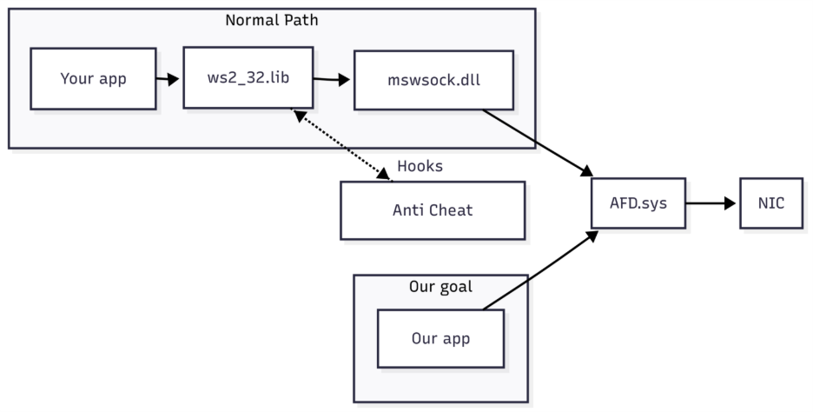
Figure 1. Diagram on how AFD.sys is usually accessed versus how we access it

  - What is SAN?
SAN (System area network) is a high-performance, connection-oriented network that can link a cluster of computers. It typically offers high bandwidth, low latency connections that are more reliable than Ethernet and ATM. It runs on its own protocol stack that bypasses the need to go through the operating system’s TCP/IP protocol stack (in other words bypassing the kernel), and instead directly performs I/O calls in memory. Also known as Remote Direct Memory Access (RDMA). This significantly reduces latency and CPU overhead.
AFD handles the kernel-side coordination for SAN connections: managing endpoint state transitions between the normal TCP path and the SAN provider, facilitating connection handoffs during accept/connect operations, and transferring context (address information, buffer mappings) between the standard socket infrastructure and the SAN provider.
In modern developments, the technology is referred to as InfiniBand and/or RDMA over Converged Ethernet (RoCE). Microsoft has deprecated Windows Sockets Direct (what SAN was developed on) in 2012, and recommends NetworkDirect and Network Direct Kernel (NDK) as its replacements. It builds on top of Windows Sockets Direct and as a result still uses a lot of same mechanisms defined for Windows Sockets Direct providers.
This is all to say that it’s not much of a stretch to say that a lot of functions used with SAN would still exist within the Winsock architecture, largely for backwards capability reasons. Microsoft is also historically conservative when it comes to removing old code paths, as doing so might lead to breaking other obscure enterprise setups.
  - Environment
While Windows 11 does support RDMA, it’s restricted to client-only functionality. In other words, it cannot make SAN endpoints, which is required to trigger the vulnerability.
Windows Server 2022 was used instead, for being more accessible to the vulnerable code. That said, the vulnerable code technically exists in Windows versions that only have client-only functionality, as it's listed in the CVE MSRC page as an affected version. Why that vulnerable code exists in those versions is unknown.

- Analysis
  - Patch diffing
Initially, the two AFD.sys versions used were afd.sys.x64.10.0.26100.7705 and afd.sys.x64.10.0.26100.7824, as the vulnerability was originally targeted to Windows 11 23H2/24H2 versions.
Whilst looking at what functionality we would need to use to reach SAN related functionality, we noticed that there was a check in AfdSanCreateHelper which used MmIsThisAnNtAsSystem to determine if the system was a server-based operating system. Based on this, we decided to examine other versions of AFD.sys for additional analysis as well.
The AFD version that was eventually used for vulnerability analysis is afd.sys.10.0.25398.2149.
We’ve performed patch diffing between afd.sys.10.0.25398.2149 and afd.sys.10.0.25398.2097, between afd.sys.10.0.26100.7705 and afd.sys.10.0.26100.7824, as well as between afd.sys.10.0.26100.7623 vs afd.sys.10.0.26100.7824. We noticed that the code between these versions did not change by a significant amount, other than certain schematics being a little different, but the methodology to reach the vulnerable code is remains exactly the same. Therefore, we are confident that the code presented below, despite coming from afd.sys.10.0.26100.7705 and afd.sys.10.0.26100.7824, will still illustrate how we perform the patch diffing.
The initial investigation with ghidriff reveals that there are a large number of modifications to the existing functions. The most notable ones include: AfdNotifyPostEvents, AfdSanConnectHandler, AfdCloseCore, AfdReceiveDatagram, AfdSanAcceptCore and AfdBind.
The Diff preview can be viewed here: https://diffpreview.github.io/?e77229d894b258343c2e86a3c26fffd5
Note that we are looking for a heap-based buffer overflow, so we are specifically checking for code that copies user-controlled data to buffers - usually this is done with memcpy/memmove. The patched code will most likely have additional code containing logic for boundary checking or changing the size of the buffer.
Looking through the diff, it was determined that not too many functions had been modified and that it was expected that manual review would be possible to find the issue.
As an experiment, we also attempted to make use of AI in the form of copilot to review these changes. This will be discussed in the appendix: “AI Patch Diffing”.
The function AfdSanConnectHandler has the following changes which looked interesting:
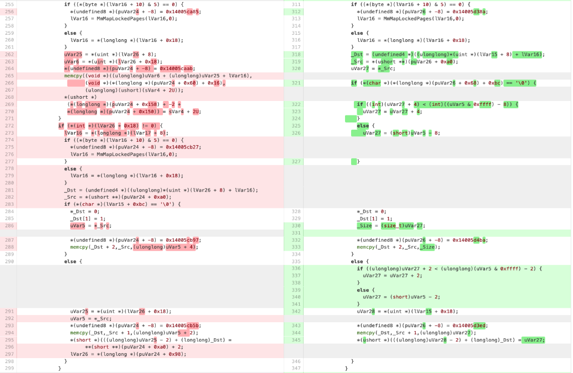Figure 2. Patch diff of AfdSanConnectHandler
On line 288 (left side), we can see a memcpy from _Src to _Dst, where the destination buffer (denoted by _Dst) is derived from lVar16 -> MmMapLockedPages(lVar16,0) and then offset by (lVar26 +8); and the source (denoted by _Src) is derived from puVar24 + 0xa0, which is user-controlled. In the unpatched version, there looked like there were no surrounding bounds checking around the memcpy that would tell if the destination buffer had a large enough buffer to accommodate the source data. Therefore, this memcpy line could potentially overflow the buffer. To confirm this, we would need to determine the size of the buffer which appeared to be allocated in a different function. The same story could also apply to line 294 (left side). Whereas in the patched version, we can see that there is additional boundary checking code from line 322 to line 326 (right side):
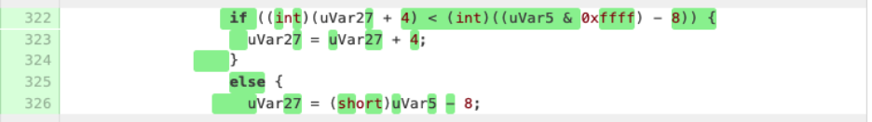
Figure 3. AfdSanConnectHandler code lines from 322 to 326
and from line 336 to line 341 (right side). Both of which comes right before the memcpy line.
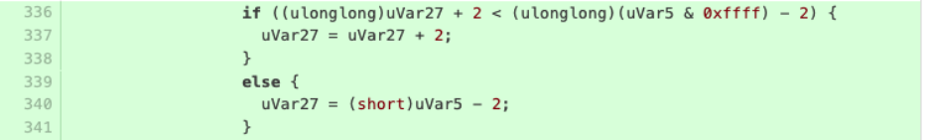
Figure 4. AfdSanConnectHandler code lines from 336 to 341
uVar27 is *_Src based on an earlier assignment on line 326 (right side). uVar5 appears to be the size field for the destination buffer. This is because uVar5 contains the value *(uint *)(lVar15 + 0x18), in which uVar5 most likely contains the size allocated to the AfdSuperAccept buffer by acquiring the value from the IRP stack (which was not previously being checked) before the copy size was used.
  - Dynamic Analysis
Moving from the static analysis, let's see how this looks like under a debugger. We will be using Python code to make calls to AFD and hitting the vulnerable portion of the code while we are at it. Some previous works have been done on this already, so we referenced the research from Akamai, to speed up the production of said POC code.
The setup:
- Create an AF_INET socket using NtCreateFile. Once a file object has been created, all subsequent communications will be done via NtDeviceIoControleFile.
- Another handle is created and will be used by AfdSuperAccept to act as a listener and accept IRP requests made from AfdSanConnectHandler
- Bind the socket to any address using IOCTL AfdBind (NtDeviceIoControlFile with ioctl 0x12003).
- Hit the vulnerable call by calling AfdSanConnectHandler (NtDeviceIoControlFile with ioctl 0x120E2)
To do this, we first create a socket which will open a handle to /Device/Afd/Endpoint via NTCreateFile.
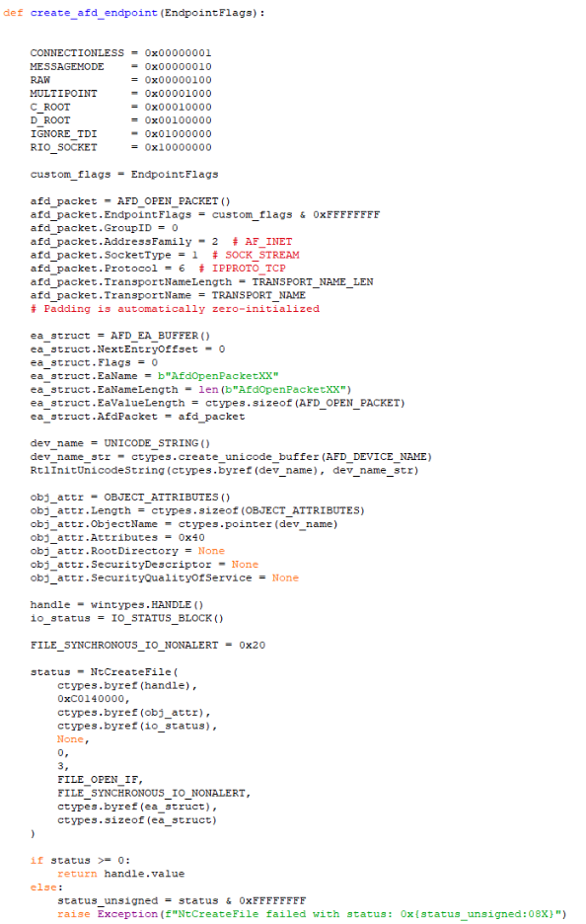
Figure 5. Code to create the AFD endpoint
This same code is used to setup the listener handle.
Once the socket has been created, it must bind to an address in order to interact with it. Thus, we need to make a call to AfdBind to bind the socket to an address.
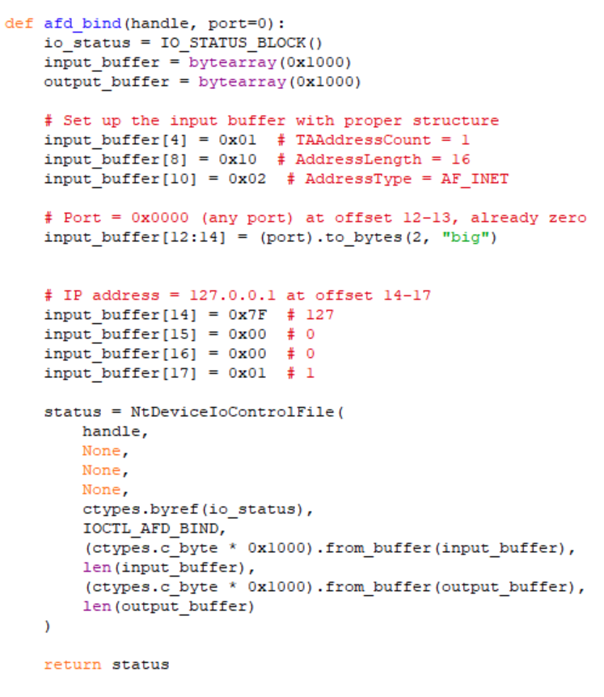
Figure 6. Code to bind the AFD endpoint to a network address

After the socket has been bound to an address, we can start making the call to AfdSanConnectHandler.
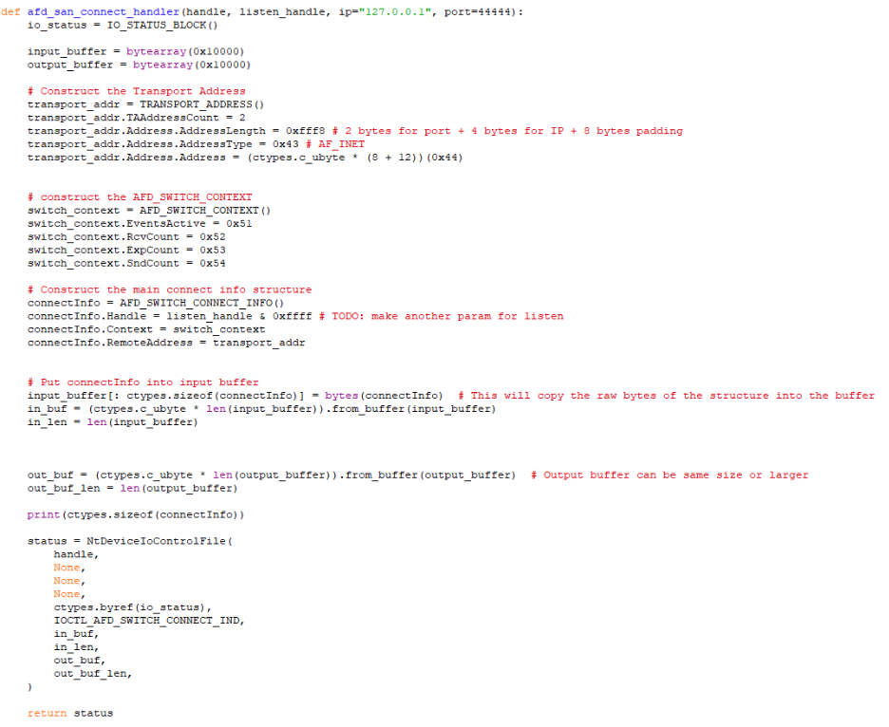
Figure 7. Code that sends an IRP request to AFDSanConnectHandler

Here is what it looks like put together within main:
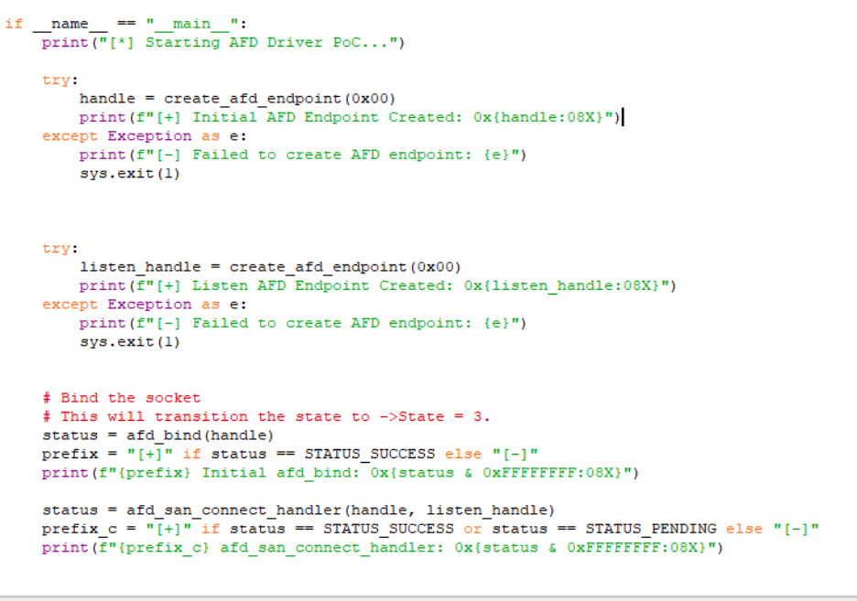
Figure 8. Main function to hit the vulnerable code paths

When this has been executed on the Windows Server 2022 VM and can see it on the debugger that AfdSanConnectHandler has been triggered.

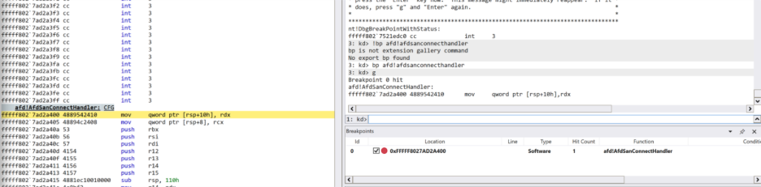
Figure 9. AFDSanConnectHandler being triggered within the debugger

Here is when the script has completed execution. The call to AfdSanConnectHandler here did not successfully complete here due to needing additional code to create a SAN handle and properly setup a listener handle (This will be fix later on)
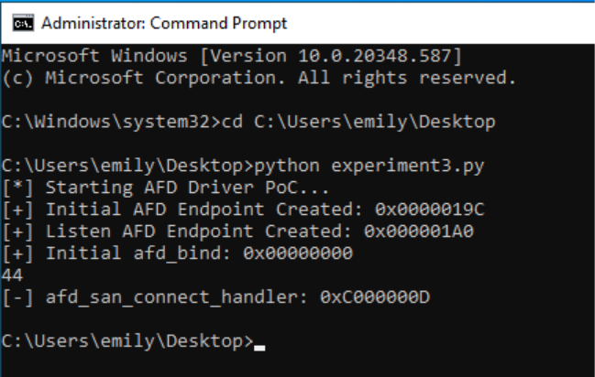
Figure 10. Completed execution of the script.
  - Vulnerability analysis
AfdSanConnectHandler is used in conjunction with AfdSuperAccept. The previously created handle is used by AfdSuperAccept so it can be the listener handle for AfdSanConnectHandler. AfdSuperAccept uses the handle to create a buffer in memory. When AfdSanConnectHandler is called, the data from that IRP request is written into that same buffer created in AfdSuperAccept. Since the data and the data length from AfdSanConnectHandler are user-controlled, it is possible to overflow the buffer created by AfdSuperAccept.
We can see this in the disassembled code of AfdSuperAccept (variables and parameters have been relabelled for clarity):
One of the first lines you see is Type3InputBuffer. This variable contains the user-controlled data from the IRP request for AfdSuperAccept as shown here.
`Type3InputBuffer = (byte *)irpSp->Parameters.DeviceIoControl.Type3InputBuffer;`
Next, we can see the key variables being initialized that determine the length of each section of the AfdSuperAccept buffer: ReceiveDataLength, RemoteAddressLength, ReceiveDataLength.
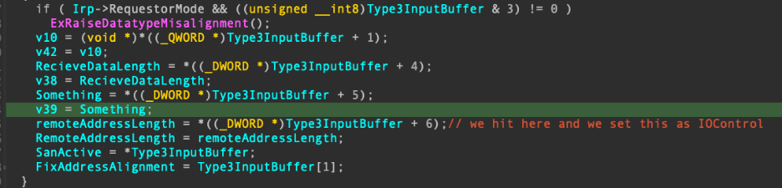
Figure 11. Disassembled code within AFDSuperAccept function (1)
The variable TotalLength contains the length of the buffer for AfdSuperAccept. We can see that it is user-controlled based on the containing variable Type3InputBuffer, which comes from the IRP request.
There was also some sanity checking of the lengths here before the buffer is allocated. Basically, the function verified that the sum of ReceiveDataLength, RemoteAddressLength, ReceiveDataLength does not exceed TotalLength; and that each section of the buffer has enough space to accommodate each other.
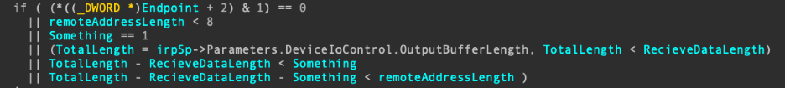
Figure 12. Disassembled code within AFDSuperAccept function (2)
Moving further down the code, we can see the call to IoAllocateMdl and MmProbeAndLockPages to create a memory map of the buffer for AfdSuperAccept. The TotalLength is what gets passed into IoAllocateMdl to allocate the buffer.
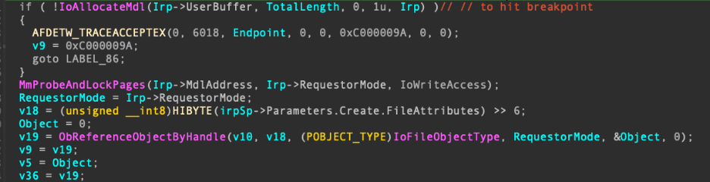
Figure 13. Disassembled code within AFDSuperAccept function (3)
Moving onto AfdSanConnectHandler, here is the code of where address of the buffer is assigned:
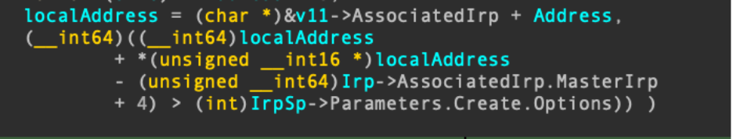
Figure 14. Disassembled code within AFDSanConnectHandler function (1)
Moving down the code and we can see how it's used with the vulnerable memcpy line (denoted as memmove here):
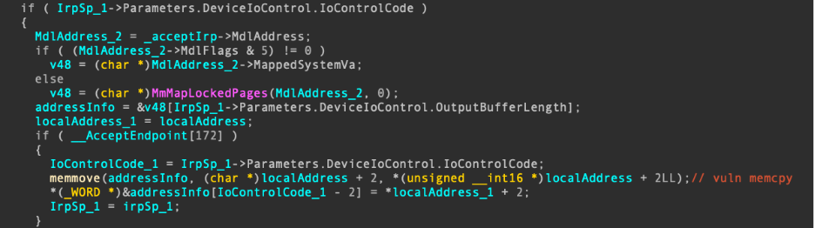
Figure 15. Disassembled code within AFDSanConnectHandler function (2)

As mentioned previously, localAddress is the user-controlled source buffer that we can use to copy a larger than expected size into the addressInfo buffer (see above) within AfdSanConnectHandler.
We can see that memmove in AfdSanConnectHandler copies into the buffer allocated in AfdSuperAccept for the size read from the DeviceIoControl input data (localAddress+2). Notice that there is no boundary checking to verify that the buffer from AfdSanConnectHandler will fit into the AfdSuperAccept buffer prior to the patch. Therefore, if the buffer from AfdSanConnectHandler is somehow bigger than the buffer from AfdSuperAccept, this would cause the buffer to overflow.
- Proof of Concept (POC)
  - Creating the POC code
We need to create another type of handle called: SAN handle. A normal socket calling AFD uses the extended attribute (EA) named: AfdOpenPacketXX. A SAN handle is created using the EA: AfdSwOpenPacket. The EA is eventually passed to AfdSanCreateHelper to create the SAN handle.
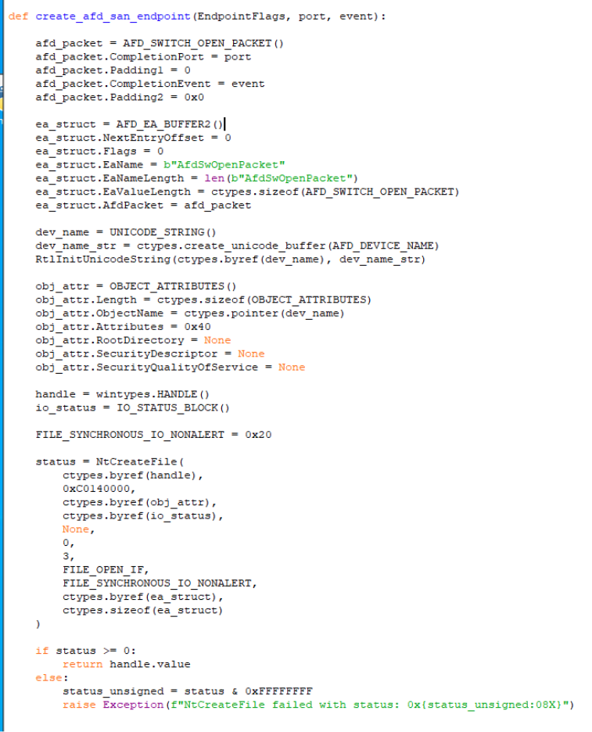
Figure 16. Code to create the SAN endpoint
AfdSuperAccept has been fixed to properly create the listener handler:
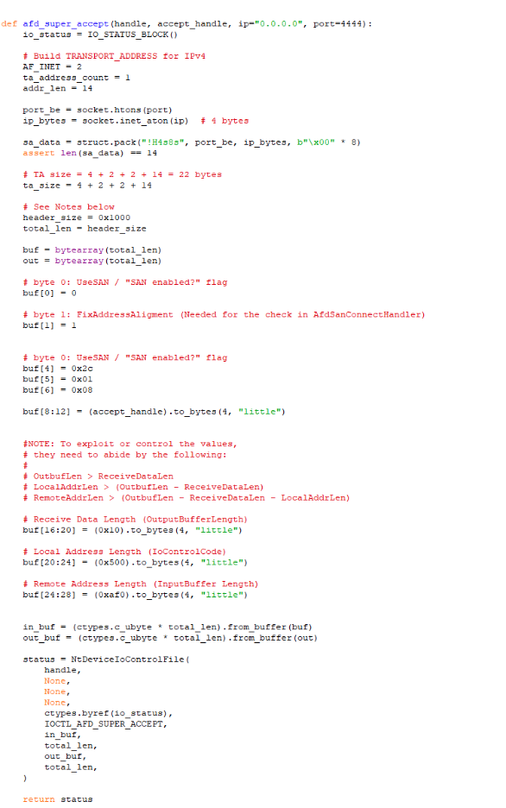
Figure 17. Code to create valid Accept Handle

The key thing to note here is header_size (total_len) is the size of the input and output buffer. This means in our example, the buffer will be allocated of size 0x1000.
Now make a call to AfdSanConnectHandler with the following function:
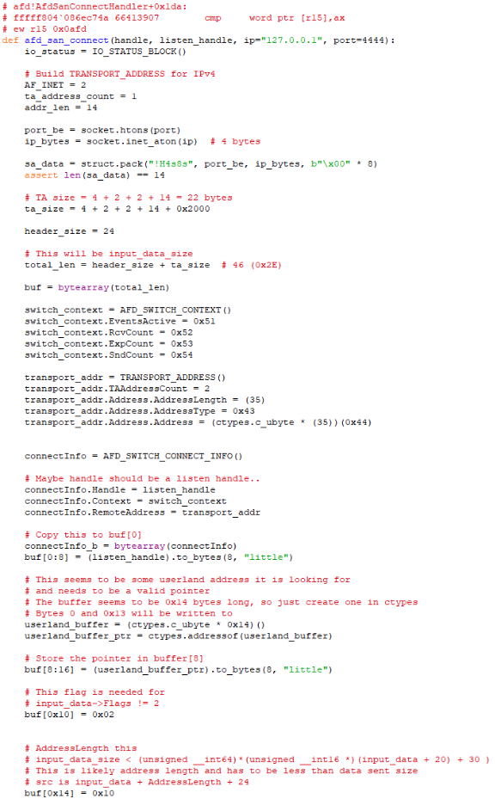
Figure 18. Code to create the SAN Connect Handle

Some important things to note here:

- To demonstrate the buffer overflow, 0x1000 worth of ‘A’ followed by 0x1000 worth of ‘B’ will be set within the buffer to show the overflow.

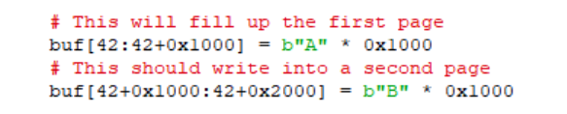
Figure 19. Distinguish boundary between first page and second page
- ta_size in this case has 0x2000 added to it, so that the input buffer in_buf which is provided to the DeviceIoControl when AfdSanConnectHandler is called, has enough space to accommodate the 0x2000 payload size to trigger the overflow.

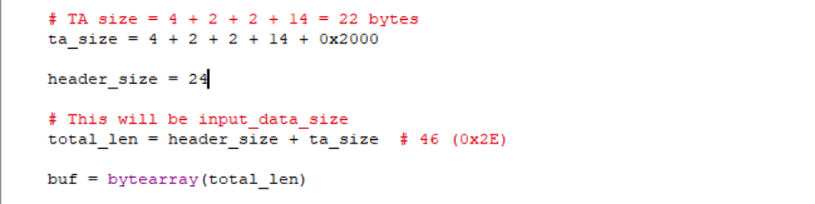
Figure 20. Setup Corrupting Buffer
- While reverse engineering the function, we noticed that the buffer also required another field, possibly AddressLength, as src appears to be input_data + AddressLength + 24.
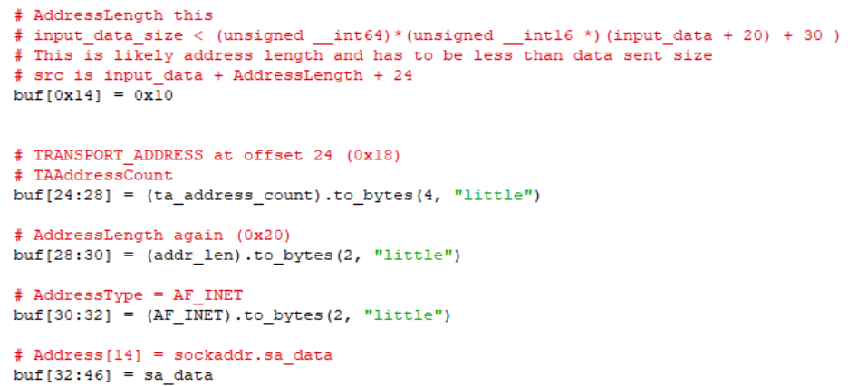
Figure 21. Adding AddressLength and additional setup flags to the buffer

- Below are the bytes that show that we were able to control the memcpy/memmove code. This dictates the amount of data that gets copied into the AFDSuperAccept buffer. In this case, the memmove size is designated as 0x2002.
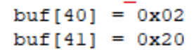
Figure 22. Memcpy size (0x2002 bytes)

Putting it all together, this is what the main function looks like:
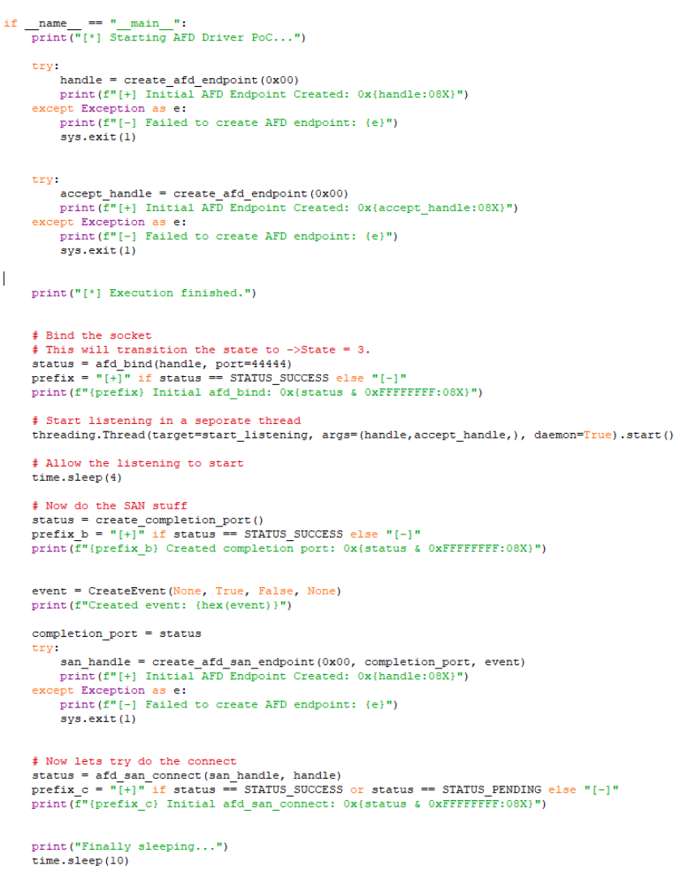
Figure 23. Proof-of-Concept code

We run the code, and we can see that the debugger encounters a fatal system error:
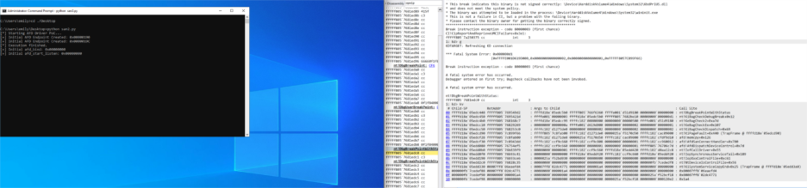
Figure 24. Proof-of-Concept In Progress

The call stack:
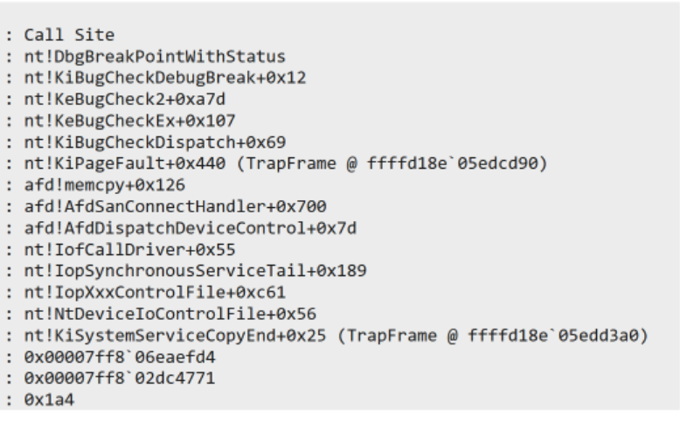
Figure 24. Stack Trace

Followed by the BSOD screen:
Figure 25. Blue Screen of Death (BSOD)

Here’s what it looks like in the debugger:
First, we make a breakpoint within AfdSuperAccept, right before the call to IoAllocatedMDL.

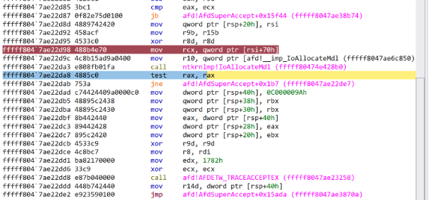
Figure 26. Debugger view

We carefully step over the function and output the rax value which contains the newly
allocated MDL address.
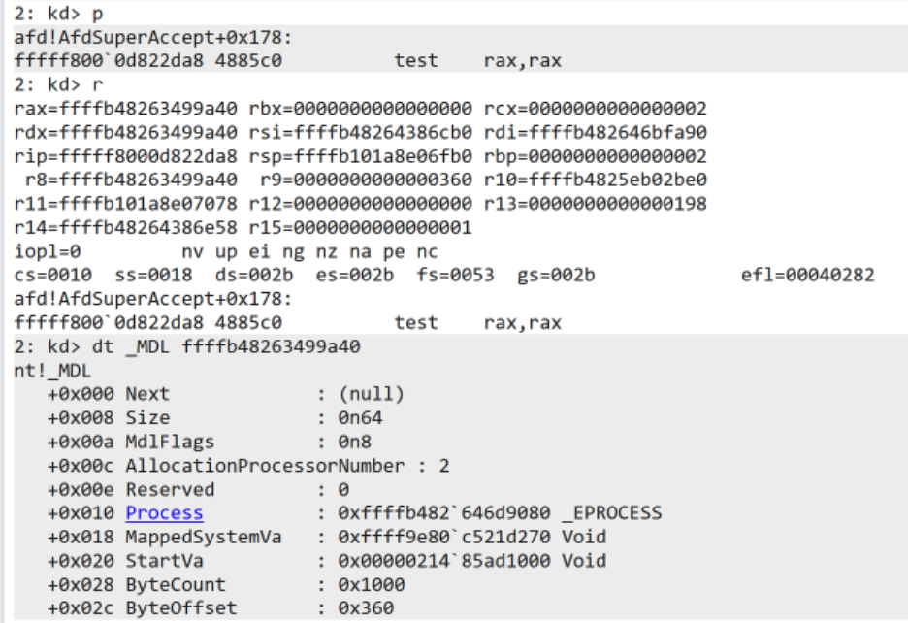
Figure 27. MDL Contents

We create another breakpoint right before the vulnerable memcpy and carefully step over that function to cause a fatal system error.
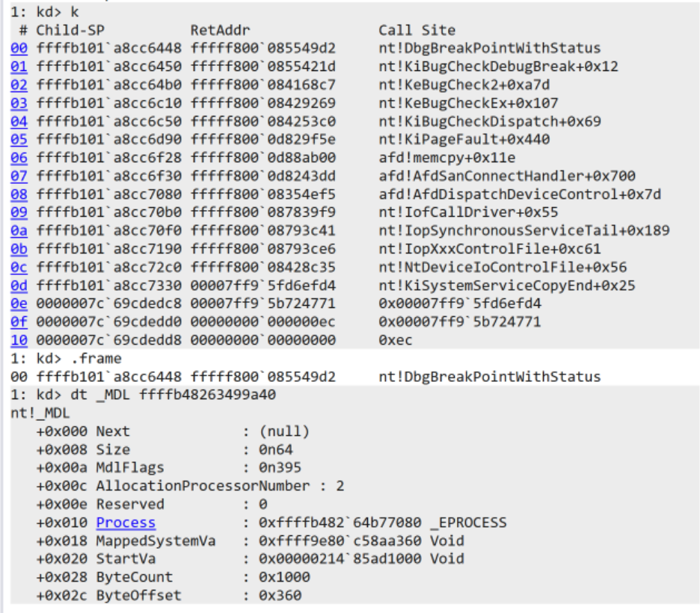
Figure 28. MDL Content (Continued)

The value from the MappedSystemVa parameter contains the virtual address (kernel side) of this buffer.
To test that the buffer has been overflowed, we can dump 2000 bytes of memory from that virtual address. The address being: 0xffff9e80`c58aa360. We can clearly see that the buffer has been filled with our payload from the script.
kd> db 0xffff9e80`c58aa360 L2000
ffff9e80`c58aa360 00 00 00 00 00 00 00 00-00 00 00 00 00 00 00 00 ................
ffff9e80`c58aa370 41 41 41 41 41 41 41 41-41 41 41 41 41 41 41 41 AAAAAAAAAAAAAAAA
ffff9e80`c58aa380 41 41 41 41 41 41 41 41-41 41 41 41 41 41 41 41 AAAAAAAAAAAAAAAA
ffff9e80`c58aa390 41 41 41 41 41 41 41 41-41 41 41 41 41 41 41 41 AAAAAAAAAAAAAAAA
ffff9e80`c58aa3a0 41 41 41 41 41 41 41 41-41 41 41 41 41 41 41 41 AAAAAAAAAAAAAAAA
ffff9e80`c58aa3b0 41 41 41 41 41 41 41 41-41 41 41 41 41 41 41 41 AAAAAAAAAAAAAAAA
ffff9e80`c58aa3c0 41 41 41 41 41 41 41 41-41 41 41 41 41 41 41 41 AAAAAAAAAAAAAAAA
ffff9e80`c58aa3d0 41 41 41 41 41 41 41 41-41 41 41 41 41 41 41 41 AAAAAAAAAAAAAAAA
ffff9e80`c58aa3e0 41 41 41 41 41 41 41 41-41 41 41 41 41 41 41 41 AAAAAAAAAAAAAAAA
ffff9e80`c58aa3f0 41 41 41 41 41 41 41 41-41 41 41 41 41 41 41 41 AAAAAAAAAAAAAAAA
ffff9e80`c58aa400 41 41 41 41 41 41 41 41-41 41 41 41 41 41 41 41 AAAAAAAAAAAAAAAA
...
41 41 AAAAAAAAAAAAAAAA
ffff9e80`c58ab330 41 41 41 41 41 41 41 41-41 41 41 41 41 41 41 41 AAAAAAAAAAAAAAAA
ffff9e80`c58ab340 41 41 41 41 41 41 41 41-41 41 41 41 41 41 41 41 AAAAAAAAAAAAAAAA
ffff9e80`c58ab350 41 41 41 41 41 41 41 41-41 41 41 41 41 41 41 41 AAAAAAAAAAAAAAAA
ffff9e80`c58ab360 41 41 41 41 41 41 41 41-41 41 41 41 41 41 41 41 AAAAAAAAAAAAAAAA
ffff9e80`c58ab370 42 42 42 42 42 42 42 42-42 42 42 42 42 42 42 42 BBBBBBBBBBBBBBBB
ffff9e80`c58ab380 42 42 42 42 42 42 42 42-42 42 42 42 42 42 42 42 BBBBBBBBBBBBBBBB
ffff9e80`c58ab390 42 42 42 42 42 42 42 42-42 42 42 42 42 42 42 42 BBBBBBBBBBBBBBBB
ffff9e80`c58ab3a0 42 42 42 42 42 42 42 42-42 42 42 42 42 42 42 42 BBBBBBBBBBBBBBBB
ffff9e80`c58ab3b0 42 42 42 42 42 42 42 42-42 42 42 42 42 42 42 42 BBBBBBBBBBBBBBBB
ffff9e80`c58ab3c0 42 42 42 42 42 42 42 42-42 42 42 42 42 42 42 42 BBBBBBBBBBBBBBBB
ffff9e80`c58ab3d0 42 42 42 42 42 42 42 42-42 42 42 42 42 42 42 42 BBBBBBBBBBBBBBBB
ffff9e80`c58ab3e0 42 42 42 42 42 42 42 42-42 42 42 42 42 42 42 42 BBBBBBBBBBBBBBBB
ffff9e80`c58ab3f0 42 42 42 42 42 42 42 42-42 42 42 42 42 42 42 42 BBBBBBBBBBBBBBBB
ffff9e80`c58ab400 42 42 42 42 42 42 42 42-42 42 42 42 42 42 ...
42 42 BBBBBBBBBBBBBBBB
ffff9e80`c58abfa0 42 42 42 42 42 42 42 42-42 42 42 42 42 42 42 42 BBBBBBBBBBBBBBBB
ffff9e80`c58abfb0 42 42 42 42 42 42 42 42-42 42 42 42 42 42 42 42 BBBBBBBBBBBBBBBB
ffff9e80`c58abfc0 42 42 42 42 42 42 42 42-42 42 42 42 42 42 42 42 BBBBBBBBBBBBBBBB
ffff9e80`c58abfd0 42 42 42 42 42 42 42 42-42 42 42 42 42 42 42 42 BBBBBBBBBBBBBBBB
ffff9e80`c58abfe0 42 42 42 42 42 42 42 42-42 42 42 42 42 42 42 42 BBBBBBBBBBBBBBBB
ffff9e80`c58abff0 42 42 42 42 42 42 42 42-42 42 42 42 42 42 42 42 BBBBBBBBBBBBBBBB
Figure 29. Hexdump of Vulnerable Buffer

Remember that the AfdSuperAccept buffer is 0x1000 in size, so if we go down to the memory at 0xffff9e80`c58aa360 + 0x1000 = ffff9e80`c58ab360. We can see that the next line being filled with ‘B’s instead of ‘A’, thus denoting the end of the 0x1000 size payload for ‘A’. In other words, we have now overflowed the buffer.

- Conclusion
This was a rather straightforward vulnerability, as we were able to control the allocation size, copy size, and actual values in the overflow. This vulnerability was present in a niche (and old) part of AFD, it can only be triggered in Windows versions that have SAN components installed. Non-Windows Server versions typically don't have them installed out-of-the box. Analysing this vulnerability has given us a better understanding of how AFD works under-the-hood and could prove a great segway into developing an exploit for it.
- Acknowledgements
Special thanks to Alex Plaskett and Robert Herrera for providing support and guidance during the secondment.

- Appendix A
  - AI Patch Diffing
As part of this project, we briefly experimented using LLMs applied to the patch diffing process and speeding up reviewing of changes.
Quite simply in this instance we provided the LLM with each pre-patched function and post-patch function one by one with no manual clean-up.
We then promoted the LLM with the following simple prompt replacing <function_name> with each function in turn:
A Heap-based buffer overflow in Windows Ancillary Function Driver was fixed within afd.sys.10.0.26100.7824. afd.sys.10.0.26100.7633 was vulnerable. Attached are two versions of a function <function name>. Where is the heap buffer overflow? Do not use any other local context other than the attached file.
This led to the following output from copilot (GPT-5)
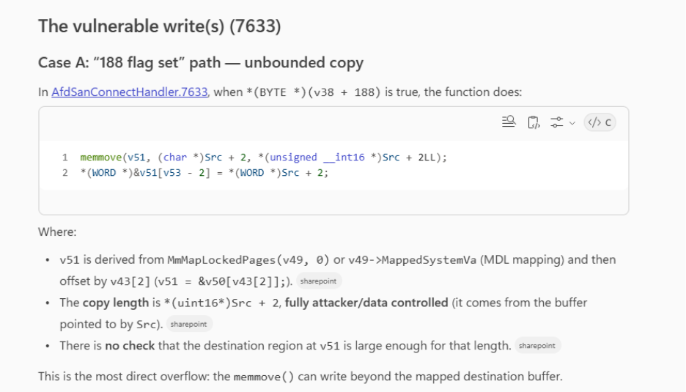
Figure 30. AI Analysis 1

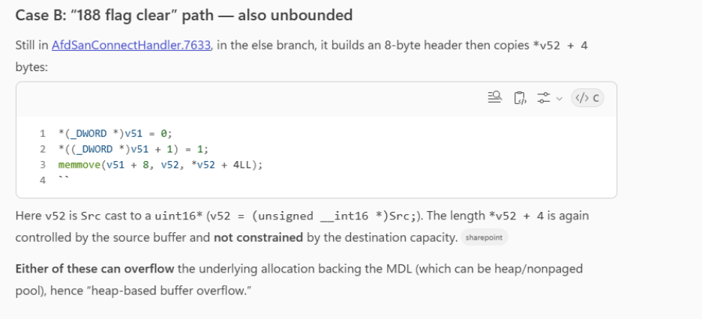
Figure 31. AI Analysis 2

The vulnerability itself wasn’t especially complex and it could be determined entirely in the context of the function itself without caller or callee context. However, the output here was accurate and supported by our manual analysis of the vulnerability itself, thus lending credence to other researchers who have published that AI applied to binary patch analysis could reduce the amount of analyst time required.
This would be especially helpful if integrated into an automated AI patch analysis pipeline. It was also noted that the LLM identified other security related issues also fixed within this patch release (Use After Free) which are not covered here. However, much more evaluation would be needed to be performed to assess effectiveness in depth and across different vulnerability classes.

https://leftarcode.com/posts/afd-reverse-engineering-part1/
https://learn.microsoft.com/en-us/windows-hardware/drivers/network/introduction-to-system-area-networks
https://learn.microsoft.com/en-us/windows-hardware/drivers/network/background-reading-on-rdma?source=recommendations
https://learn.microsoft.com/en-us/previous-versions/windows/it-pro/windows-server-2012-R2-and-2012/hh831568(v=ws.11)
https://github.com/microsoft/NetworkDirect/blob/master/docs/NetworkDirectSPI.md
https://learn.microsoft.com/en-us/windows-hardware/drivers/network/overview-of-network-direct-kernel-provider-interface--ndkpi-
https://learn.microsoft.com/en-us/windows/win32/winsock/windows-sockets-2-architecture-2
https://docs.tuxera.com/docs/legacy-docs/how-to-articles/rdma-supported-versions-of-windows-10-11/
https://learn.microsoft.com/en-us/windows-server/storage/file-server/smb-direct?tabs=disable
https://msrc.microsoft.com/update-guide/en-US/vulnerability/CVE-2026-21236
https://learn.microsoft.com/en-us/windows-hardware/drivers/ddi/ntddk/nf-ntddk-mmisthisanntassystem
https://github.com/clearbluejar/ghidriff

